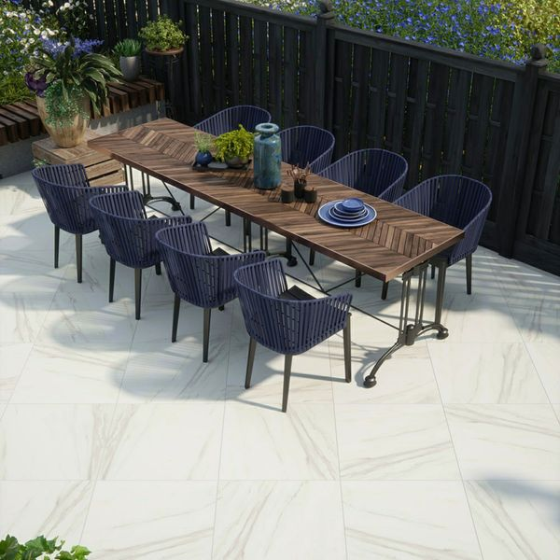

Calacatta Gold Porcelain: <https://www.wallsandfloors.co.uk/calacatta-gold-matt-20mm-slab-tiles>

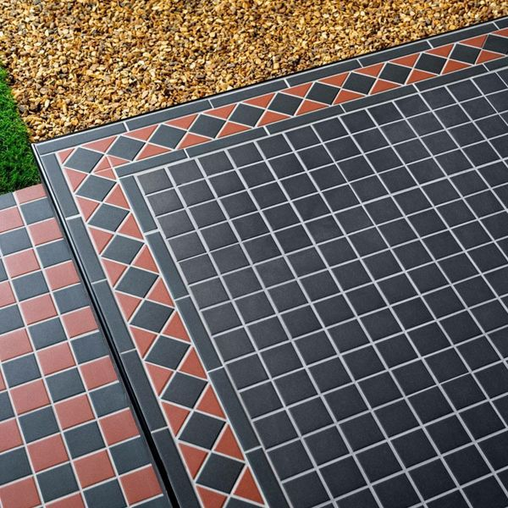

Churchill Midnight Mosaic: <https://www.wallsandfloors.co.uk/churchill-midnight-mosaic-tiles>

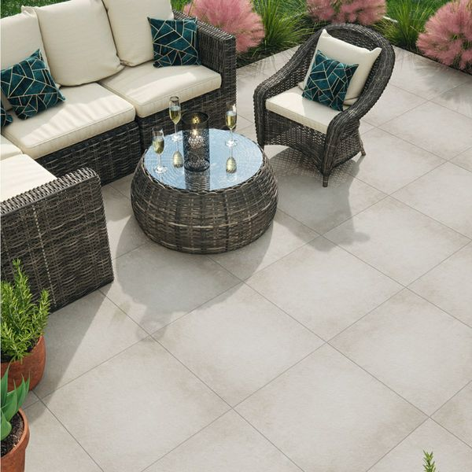

Leinz Grey Porcelain: <https://www.wallsandfloors.co.uk/leinz-grey-slab-tiles>

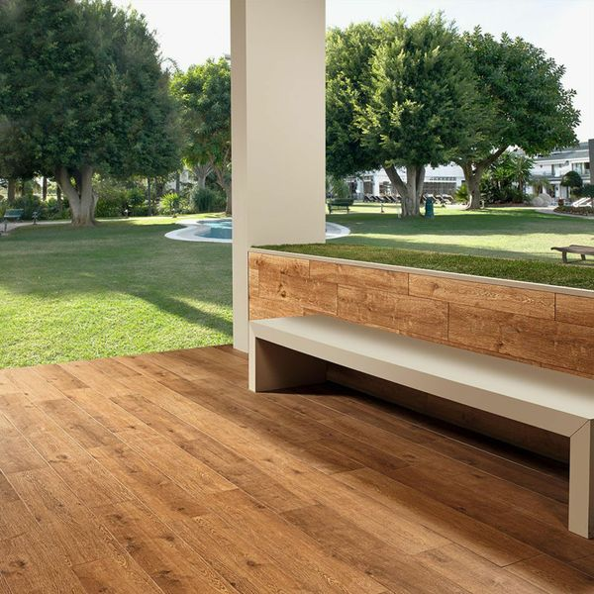

Madagascan Ipil: <https://www.wallsandfloors.co.uk/dark-honey-tiles>

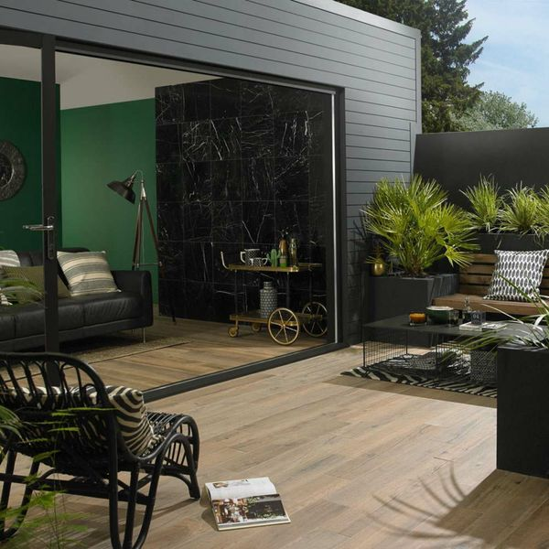

Muniellos Honey Oak: <https://www.wallsandfloors.co.uk/honey-oak-910x153-anti-slip-tiles>

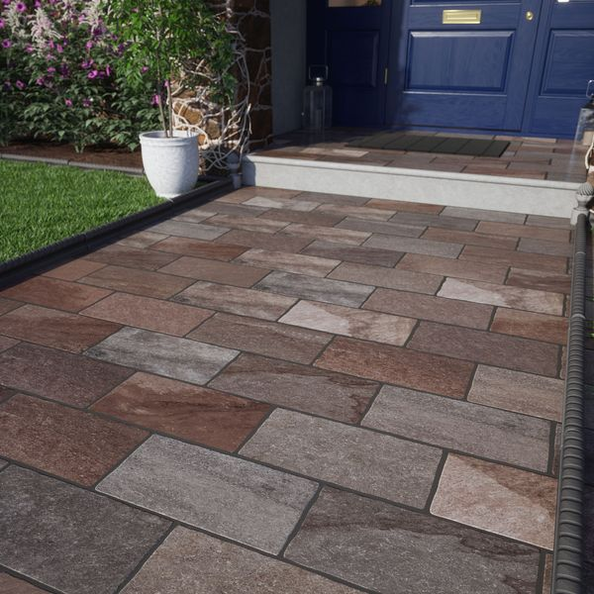

Trail Terra: <https://www.wallsandfloors.co.uk/trail-terra-20x30-matt-slab-tiles>